**Content**

1. Codewars – streams 2

1. Example1 2

1. Codewars – streams
   1. Example1

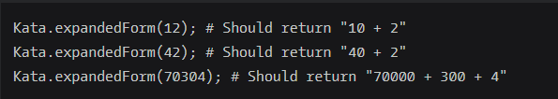

import java.util.stream.Collectors;

import java.util.stream.IntStream;

public class Kata

{

public static String expandedForm(int num)

{

return IntStream.range(0, String.valueOf(num).length())

.mapToObj(x -> String.valueOf( Character.getNumericValue(String.valueOf(num).charAt(x) ) * (int)Math.pow(10, String.valueOf(num).substring(x).length()-1)))

.filter(x -> !x.equals("0"))

.collect(Collectors.joining(" + "));

}

}

* 1. Example2



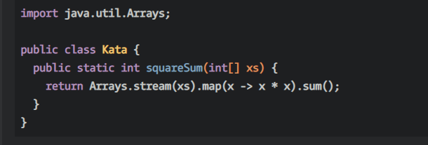

* 1. Example3

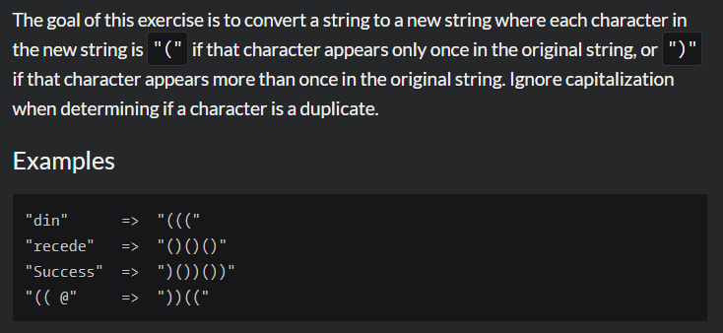

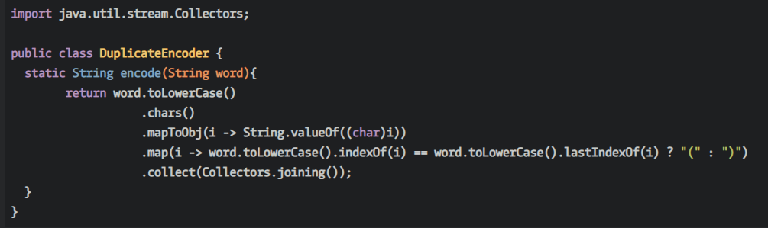

* 1. Example4

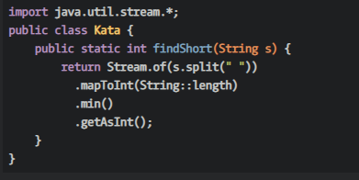

* + 1. Difference between Stream.of and Array.stream
  1. Example5

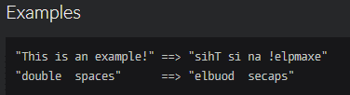

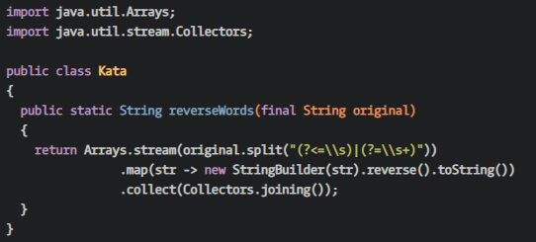

* 1. Example6

